This assessment is about the identification of I/O ports and devices linked to a computer. It is easy to accidentally unplug an I/O device. If you do, knowledge of the ports and the devices that connect to them will help you correctly reconnect the device.
Required Setup and Tools
In this laboratory, you need to:
- Look at the outside of a desktop or notebook computer.
- Access to the Internet for research.

Recommended Procedures
Task 1: Identify the Ports
Procedure
- Look at the front and back of a desktop or notebook computer for the following bus connectors: RS232, USB, FireWire, and infrared. How many of each type of connector did you find?
- Label the appropriate names to the ports and adaptors given below.
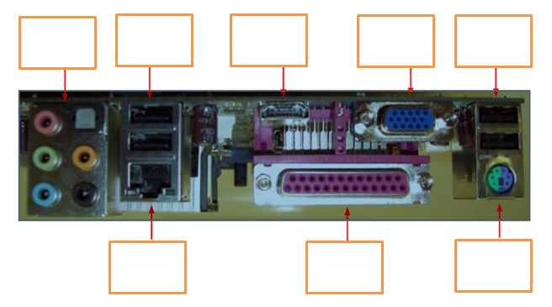
Task 2: Identify Memory Slots
Procedure

- Using the Internet, locate a diagram or photo of these types of memory slots on a desktop or notebook computer: Memory Stick (MS), Micro Drive (MD), Compact Flash (CF), and Secure Digital (SD).
- Explain the diagram or photo(s) with the name of each type of memory slot.

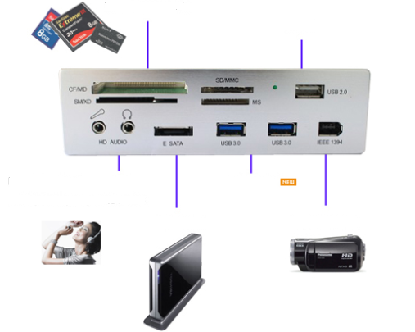
Examples:

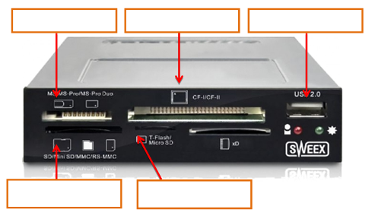

Task 3: Identify the Configuration
Procedure
- Identify the following configuration.
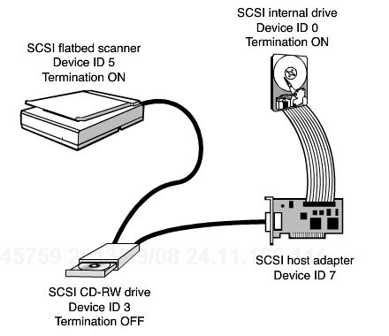

- Define a SCSI and the need to use a SCSI Controller.

Task 4: Identify the Color Codes
Procedure
Most recent systems and sound cards use the PC 99 color coding list. Fill in the table
Color | Description
Pink
Light Blue
Lime Green
Brown
Orange

Task 5: Identify the Following
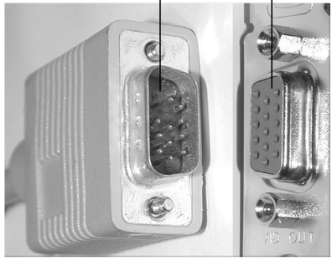

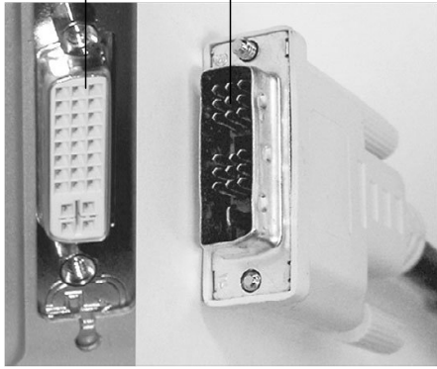

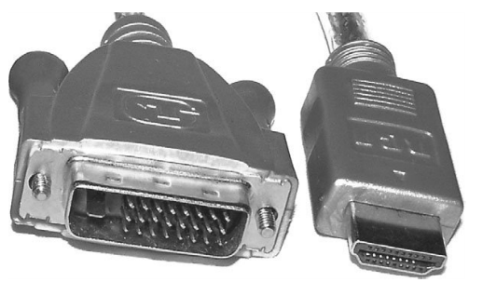

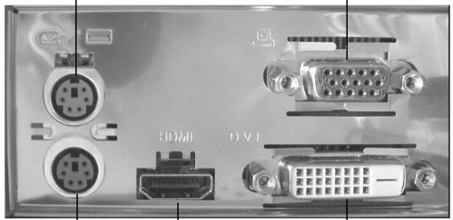

Submission Requirements:
- Microsoft Word document containing descriptions of the results obtained in each step of the procedure for each task, including relevant screenshots, tables, and/or diagrams. Note: To grab a screenshot of the current window, such as the Internet Explorer window, press the Alt and Print Screen keys to put a copy of the screenshot onto the Windows clipboard, then switch to your Microsoft Word document and paste the screenshot into your document.
- Your report should be four- to five-page long. Include a header containing your name and the date on each page. Name the document NT1110_StudentName_Module2_Lab.doc, replacing StudentName with your name. Use Arial 12-point font and double-line spacing.
Evaluation Criteria:
The Lab rubric will be used to evaluate this assessment.

