In this lab, you will demonstrate the ability to examine and investigate the different types of motherboards and CPUs used in a computer.
Required Setup and Tools
Photos of motherboards and CPUs are provided in the lab worksheet. However, if possible, the case cover of a desktop computer should be removed in order to get a look inside the system at the motherboard. The system should be unplugged and off when this work is done. You also need access to the Internet for research.
Use the Lab 3 Worksheet to submit your responses.
Recommended Procedures
Task 1: Examine the Motherboard
Procedure
- Examine the following motherboard. One interesting thing you will see is the use of two BIOS chips. The M-BIOS chip is the Main BIOS chip and the B-BIOS chip is the Backup BIOS chip, which is used to rewrite the M-BIOS chip if it becomes corrupted. (Refer to the high-resolution images for closer inspection.)
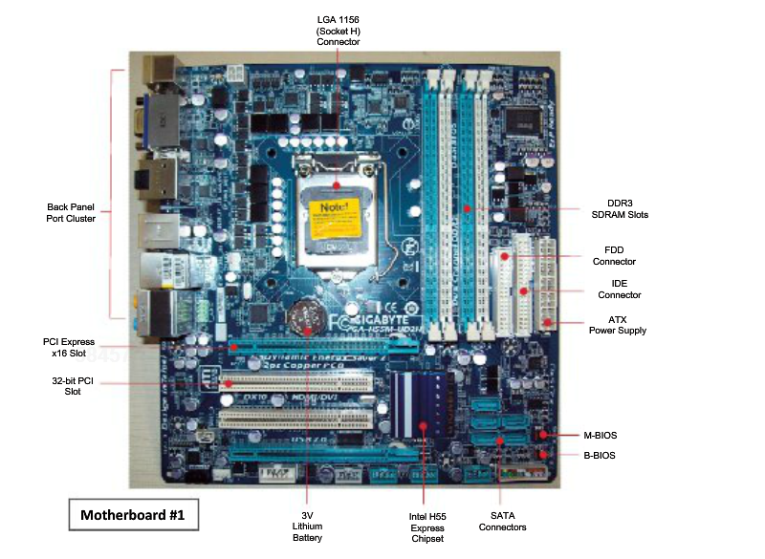
- Using the Internet, locate information on the LGA 1156 connector. What processors is it used with? What is its purpose on the motherboard?
- Using the Internet, locate information on the Intel H55 Chipset. What processors is it used with? What is its purpose on the motherboard?
- Using the Internet, locate information on the Gigabyte GA-H55M-UD2H motherboard. What interesting information can you find?
Task 2: Examine the Chipset and Connectors
- Examine the following motherboard. (Refer to the high-resolution images for closer inspection.)
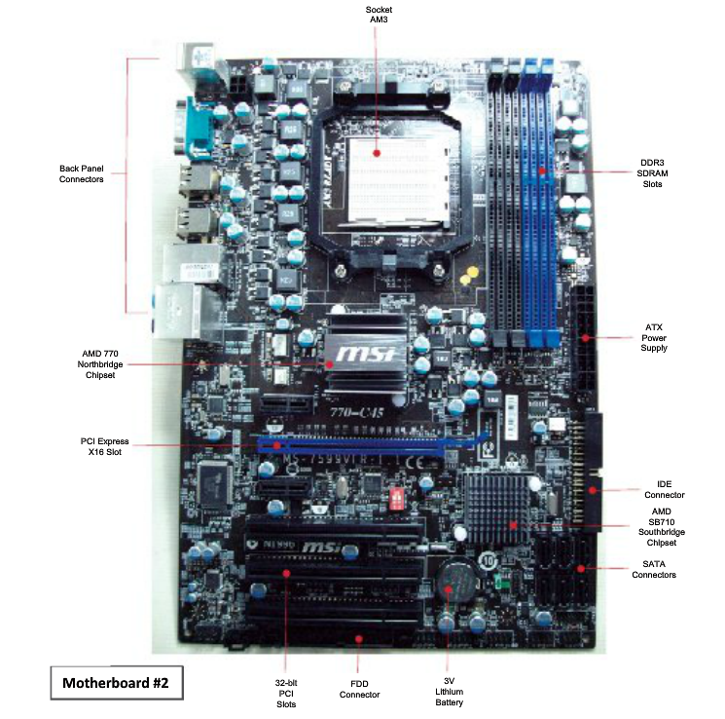
- Using the Internet, locate information on the AMD 770 Northbridge Chipset. What processors is it used with? What is its purpose on the motherboard?
- Using the Internet, locate information on the AMD SB710 Southbridge Chipset. What processors is it used with? What is its purpose on the motherboard?
- Using the Internet, locate information on the Socket AM3 Connector. What processors is it used with?
Task 3: Examine Intel Processors
Procedure
- Use the Internet to locate information on the Intel processors listed in the following table. Fill in all the column values.

Processor | Clock Speed | Internal Cache | Bus Speed | Architecture
I7
I7 mobile
I5
I5 mobile
I3
I3 mobile
vPro
vPro mobile
Xeon 7000
Xeon 5000
Xeon 3000
Itanium 9000
Pentium
Celeron

- Examine the following Intel CPU. The information printed on the top of the CPU reads as follows: Intel E5300, Pentium Dual-Core, 2.6GHZ/2M/800. What does each portion of the processor description indicate?
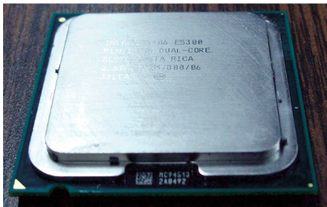

- Here is the bottom view of the same CPU. Indicate where the pins are? What kind of processor package style is this?

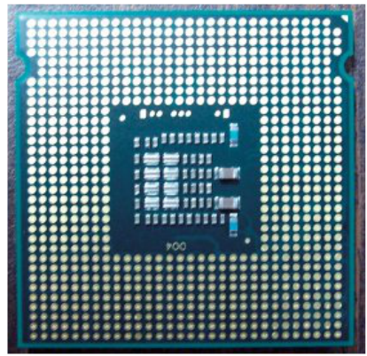

- Use the Internet to locate information on the AMD processors listed in the following table and fill in all the column values.

Processor | Clock Speed | Internal Cache | Bus Speed | Architecture
Phenom II
Phenom
Athlon II
Athlon X2 Dual-Core
Athlon
Sempron
Opteron
Turion
AM3/AM2

Submission Requirements:
- Your lab report will be a Microsoft Word document containing descriptions of the results obtained in each step of the procedure for each task, including relevant screenshots, tables, and/or diagrams. Note: To grab a screenshot of the current window, such as the Internet Explorer window, press the Alt and Print Screen keys to put a copy of the screenshot onto the Windows clipboard and then switch to your Microsoft Word document and paste the screenshot into your document.
- Include a references page citing the resources you used from the textbook, ITT Tech Virtual Library, and credible websites to substantiate your answers. All citations should be in APA format. Refer to ITT Tech Virtual Library> Research Help> Research Guides> Grammar, Writing & Style> APA Formatting and Style Guide for help in APA formatting.
- Your report should be six- to eight-page long. Include a header containing your name and the date on each page. Name the document NT1110_StudentName_Module3_Lab2.doc, replacing StudentName with your name. Use Arial 12-point font and double-line spacing.

Evaluation Criteria:
The Lab rubric will be used to evaluate this assessment.

