In this lab, you will demonstrate the ability to work with decimal and hexadecimal numbers.
Required Setup and Tools
In this lab, you will need only paper and pencil to do the required work. However, the use of a calculator is permitted to verify the results of a calculation. The Windows calculator may be used for this purpose.
Recommended Procedures
Task 1: Convert Decimal Number into Binary
Procedure
- Convert the decimal number 125 into binary. Use the division-by-two method shown in the following example below.
- Convert your binary result back into decimal to prove your answer is correct. This is also shown in the following example.
Example:
Convert the decimal number 50 into binary using the division-by-two method. Convert the binary result back into decimal.
Solution:
50/2= 25
25/2= 12 remainder 1
12/2= 6 remainder 0
6/2= 3 remainder 0
3/2= 1 remainder 1
1/2= 0 remainder 1 (most significant bit [MSB])
Read the answer from bottom (MSB) to top least significant bit (LSB): 110010
Convert 110010 binary into decimal.
Weights 32 16 8 4 2 1
Bits 1 1 0 0 1 0
Adding the weights whose bits are 1: 32 + 16 + 2 = 50
Task 2: Convert Binary Number into Decimal
Procedure
- Convert the binary number 10101101 into decimal. Use the method of adding weights, as shown in the example, from Task 1.
- Use the Windows calculator to prove your answer is correct. This process is shown in the following example.
Example:
Use the Windows calculator to prove that the binary number 110010 equals 50 decimal.
Solution:
First, start the Windows calculator by clicking Start and then clicking Run. Enter calc in the Open text box and then click OK. Alternatively, you can open the Accessories folder and select Calculator.

When the Windows calculator starts up, you should see the following window:
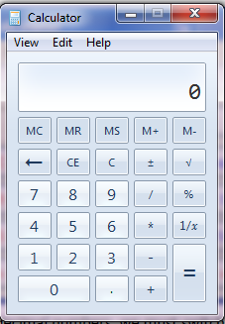
To be able to use binary and hexadecimal numbers, we must switch the calculator mode to scientific mode. Click View on the toolbar and then choose Programmer.
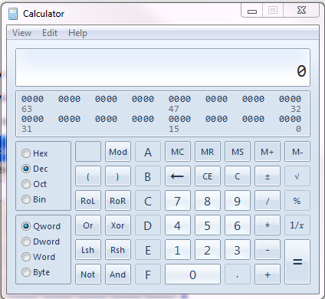
To enter a binary number, first click the Bin radio button. Then, enter all the binary bits by clicking the 0 and 1 buttons.
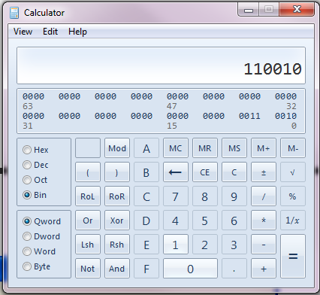

To convert the binary number in the display into decimal, click the Dec radio button.
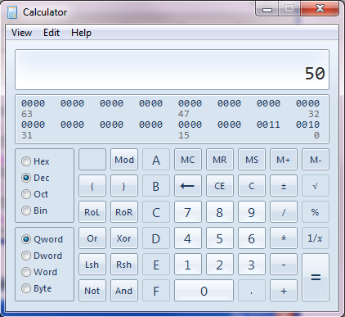

Task 3: Convert Decimal Number into Hexadecimal
Procedure
- Convert the decimal number 210 into hexadecimal. Use the division-by-sixteen method shown in the following example.
- Convert your hexadecimal result back into decimal to prove your answer is correct. This is also shown in the following example.

Example:
Convert the decimal number 50 into hexadecimal using the division-by-sixteen method.
Solution:
50/16= 3 remainder 2 (least significant digit [LSD])
3/16= 0 remainder 3 (most significant digit [MSD])
Read the answer from bottom (MSD) to top (LSD): 32
Convert 32 hexadecimal into decimal.
Weights 16 1
Digits 3 2
Multiply each weight by its corresponding digit and add the two products together:
(16 * 3) + (1 * 2) = 48 + 2 = 50
Alternatively, you can also convert the decimal number into binary and then convert the binary number into hexadecimal:
50 = 110010
Break the binary number up into groups of four bits, beginning with the LSB:
11 0010
Pad the group with only two bits with leading zeros to get a four-bit group.
0011 0010
Now, convert each four-bit group into hexadecimal.
0011 = 3, 0010 = 2
00110010 = 32 hexadecimal
Task 4: Convert Hexadecimal Number into Decimal
Procedure
- Convert the hexadecimal number E7 into decimal.
- Convert the hexadecimal number E7 into binary and then convert the binary result into decimal to prove your answer is correct. Use information from all previous examples to guide you.
Submission Requirements:
- Your lab report will be a Microsoft Word document containing descriptions of the results obtained in each step of the procedure for each task, including relevant screenshots, tables, and/or diagrams. Note: To grab a screenshot of the current window, such as the Internet Explorer window, press the Alt and Print Screen keys to put a copy of the screenshot onto the Windows clipboard and then switch to your Microsoft Word document and paste the screenshot into your document.
- Your report should be seven- to eight-page long. Include a header containing your name and the date on each page. Name the document NT1110_StudentName_Module3_Lab1.doc, replacing StudentName with your name. Use Arial 12-point font and double-line spacing.
Evaluation Criteria:
The Lab rubric will be used to evaluate this assessment.

