Standard Wiring Pinouts

From: http://www.alatec.com/info/other.html

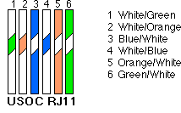 | Standard wiring for an RJ11 or RJ12 connector, pairs are made from inside out. Pair 1 is the Blue pair, Pair 2 is the Orange pair, Pair 3 is the Green pair.
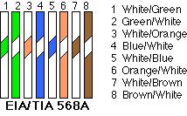 | 568A is used for a lot of Ethernet cables. It is one of the two most widely used standards. If you wire both ends of your cable using 568A, you’ll have a straight-through cable usable for most Ethernet applications. Wiring a cable with 568A on one end and 568B on the other will result in a crossover cable for connecting two hubs together, or two computers together.
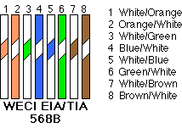 | 568B is the most widely used standard for Ethernet cables. If you wire both ends of your cable using 568B, you’ll have a straight-through cable usable for most Ethernet applications. Wiring a cable with 568A on one end and 568B on the other will result in a crossover cable for connecting two hubs together, or two computers together.
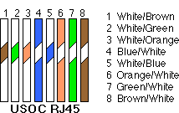 | USOC RJ45 standard is not as widely used but is an acceptable standard for wiring Ethernet. It uses the two center pins for pair one, with subsequent pairs placed to the outside of each previous pair. Usually used for straight-through cables.
 | Copyright © 2008 CP3, Inc.

CAT5e Straight-Through Cable Creation Guide

Before you begin creating your CAT 5e straight-through (patch) cable, it’s important to point out that the method outlined here is only one method. It is by no means the only or best method. Also, make sure you have all the necessary tools and materials before you begin. You will need a length of cable, several RJ-45 connectors, and a crimp tool.

- Most crimp tools have two blades: one designed to cut completely through a cable and the other designed to strip the cable jacket/insulation. Using the latter blade, strip the cable jacket/insulation back about an inch so all the wires inside are exposed. Be careful not to cut the inside wires when stripping the cable’s insulation.
- With the jacket/insulation removed, you’ll find eight wires and a string inside the CAT 5 cable. Cut the string off, and untwist the wires back to within one-eighth inch of the jacket.
- Fan the wires out from left to right in the order they are to be crimped. The crimping order depends on the type of cable you are making. For this guide, we will be wiring the cable to CAT 5 EIA 568B specifications. This is the configuration for a standard CAT 5 patch cable. (See Table and Figure below.)

How to wire a CAT5e (EIA 568B) Patch Cable
Connector #1 | Connector #2
- White/Orange | - White/Orange
- Orange | - Orange
- White/Green | - White/Green
- Blue | - Blue
- White/Blue | - White/Blue
- Green | - Green
- White/Brown | - White/Brown
- Brown | - Brown
Note: The first color listed in the color pair is the dominant color of the wire. In other words, White/Orange is a white wire with orange stripes.

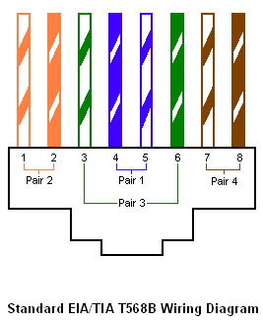

- Grasp the wires firmly between your fingers, and flatten them to remove their curliness. The wires must lay flat and together, aligned as closely as possible. Try not to get them out of order.
- While holding them firmly, cut off about a half inch of the exposed wires so they are all the same length.
- Slide the RJ-45 connector onto the wires, making sure the wires stay lined up. The connector has eight slots, one for each wire. Try to make each wire reach the end of its slot. The cable jacket/insulation should reach just beyond the end of the crimp point. If the insulation doesn’t reach far enough inside the connector, or if the wires don’t reach the end of their slots, cut the wires off a bit more. If the cable jacket/insulation reaches too far past the crimp point, simply trim off a little more jacket/insulation.
- Next, verify all the wires are in the correct order, and insert the connector into the crimping tool. Crimp it! This requires a little bit of strength, and you may need to use two hands.
- Now repeat steps 1 through 7 for the opposite end of the patch cable, and you’re finished.

NOTE: Remember that these instructions are only a general guide. Your actual experience will depend on the tools and materials you are using.
This document is provided for informational purposes only and TechRepublic makes no warranties, either expressed or implied, in this document. Information in this document is subject to change without notice. The entire risk of the use or the results of the use of this document remains with the user. The example companies, organizations, products, people and events depicted herein are fictitious. No association with any real company, organization, product, person or event is intended or should be inferred. Complying with all applicable copyright laws is the responsibility of the user. Without limiting the rights under copyright, no part of this document may be reproduced, stored in or introduced into a retrieval system, or transmitted in any form or by any means (electronic, mechanical, photocopying, recording, or otherwise), or for any purpose, without the express written permission of TechRepublic.
The names of actual companies and products mentioned herein may be the trademarks of their respective owners.

Published: Oct. 5, 2000

