Unit 7 Subnetting Lab 7

Read the lab details listed below, and then answer the questions listed in the lab exercise.

CIDR (Classless InterDomain Routing) and VLSM

CIDR (Classless Inter-Domain Routing) was introduced in 1993 (RCF 1517) replacing the previous generation of IP address syntax - classful networks. CIDR allowed for more efficient use of IPv4 address space and prefix aggregation, known as route summarization or supernetting.

CIDR introduction allowed for:
- More efficient use of IPv4 address space
- Prefix aggregation, which reduced the size of routing tables

CIDR allows routers to group routes together to reduce the bulk of routing information carried by the core routers. With CIDR, several IP networks appear to networks outside the group as a single, larger entity. With CIDR, IP addresses and their subnet masks are written as four octets, separated by periods, followed by a forward slash and a two-digit number that represents the subnet mask e.g.
10.1.1.0/30
172.16.1.16/28
192.168.1.32/27 etc
.
CIDR / VLSM Network Addressing Topology Example
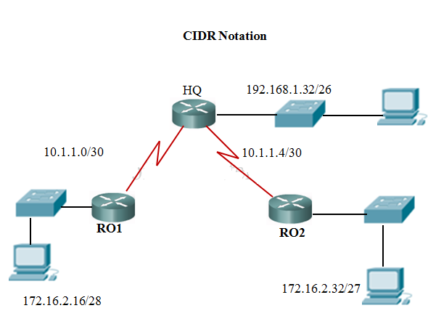
CIDR uses VLSM (Variable Lenght Subnet Masks) to allocate IP addresses to subnetworks according to need rather than class. VLSM allows for subnets to be further divided or subnetted into even smaller subnets. Simply, VLSM is subnetting a subnet.

With CIDR, address classes (A, B, and C) became meaningless. The network address are no longer determined by the value of the first octet, but assigned prefix length (subnet mask) address space. The number of hosts on a network, could now be assigned a specific prefix depending upon the number of hosts needed for that network.

Propagating CIDR supernets or VLSM subnets require a classless routing protocols. A classless routing protocol includes the subnet mask along with the network address in the routing update.

Summary Routes Determination
Determining the summary route and subnet mask for a group of networks can be done in three easy steps:
- To list the networks in binary format.
- To count the number of left-most matching bits. This will give you the prefix length or subnet mask for the summarized route.
- To copy the matching bits and then add zero bits to the rest of the address to determine the summarized network address.

The summarized network address and subnet mask can now be used as the summary route for this group of networks. Summary routes can be used by both static routes and classless routing protocols. Classful routing protocols can only summarize routes to the default classful mask.
The CIDR or “Slash” value is another means of representing the subnet mask. You simply add the number of bits used to create the mask from each octet. A 255.255.128.0 mask uses eight bits for the first octet, eight bits for the second octet, and one bit for the third octet, with none in the forth octet. 8 + 8 + 1 = 17 or represented as /17. This is the CIDR value.

ISPs could now more efficiently allocate address space using any prefix length, ISPs were no longer limited to a- 255.0.0.0 or /8, 255.255.0.0 or /16, or 255.255.255.0 or /24 subnet mask which before the advent of CIDR is known as classful network addresses. Blocks of IP addresses could be assigned to a network based on the requirements of the customer, ranging from a few hosts to hundreds or thousands of hosts.

CIDR Advantages
With the introduction of CIDR and VLSM, ISPs could now assign one part of a classful network to one customer and different part to another customer. With the introduction of VLSM and CIDR, network administrators had to use additional subnetting skills.

The table below shows allowed subnet and hosts IP address for all Classes

Class A
No. of bits | Subnet Mask | CIDR | No. of Subnets | No. of Hosts | Nets * Hosts
2 | 255.192.0.0 | /10 | 2 | 4194302 | 8388604
3 | 255.224.0.0 | /11 | 6 | 2097150 | 12582900
4 | 255.240.0.0 | /12 | 14 | 1048574 | 14680036
5 | 255.248.0.0 | /13 | 30 | 524286 | 15728580
6 | 255.252.0.0 | /14 | 62 | 262142 | 16252804
7 | 255.254.0.0 | /15 | 126 | 131070 | 16514820
8 | 255.255.0.0 | /16 | 254 | 65534 | 16645636
9 | 255.255.128.0 | /17 | 510 | 32766 | 16710660
10 | 255.255.192.0 | /18 | 1022 | 16382 | 16742404
11 | 255.255.224.0 | /19 | 2046 | 8190 | 16756740
12 | 255.255.240.0 | /20 | 4094 | 4094 | 16760836
13 | 255.255.248.0 | /21 | 8190 | 2046 | 16756740
14 | 255.255.252.0 | /22 | 16382 | 1022 | 16742404
15 | 255.255.254.0 | /23 | 32766 | 510 | 16710660
16 | 255.255.255.0 | /24 | 65534 | 254 | 16645636
17 | 255.255.255.128 | /25 | 131070 | 126 | 16514820
18 | 255.255.255.192 | /26 | 262142 | 62 | 16252804
19 | 255.255.255.224 | /27 | 524286 | 30 | 15728580
20 | 255.255.255.240 | /28 | 1048574 | 14 | 14680036
21 | 255.255.255.248 | /29 | 2097150 | 6 | 12582900
22 | 255.255.255.252 | /30 | 4194302 | 2 | 8388604

Class B
No. of bits | Subnet Mask | CIDR | No. of Subnets | No. of Hosts | Nets * Hosts
2 | 255.255.192.0 | /18 | 2 | 16382 | 32764
3 | 255.255.224.0 | /19 | 6 | 8190 | 49140
4 | 255.255.240.0 | /20 | 14 | 4094 | 57316
5 | 255.255.248.0 | /21 | 30 | 2046 | 61380
6 | 255.255.252.0 | /22 | 62 | 1022 | 63364
7 | 255.255.254.0 | /23 | 126 | 510 | 64260
8 | 255.255.255.0 | /24 | 254 | 254 | 64516
9 | 255.255.255.128 | /25 | 510 | 126 | 64260
10 | 255.255.255.192 | /26 | 1022 | 62 | 63364
11 | 255.255.255.224 | /27 | 2046 | 30 | 61380
12 | 255.255.255.240 | /28 | 4094 | 14 | 57316
13 | 255.255.255.248 | /29 | 8190 | 6 | 49140
14 | 255.255.255.252 | /30 | 16382 | 2 | 32764

Class C
No. of bits | Subnet Mask | CIDR | #No. of Subnets | No. of Hosts | Nets * Hosts
2 | 255.255.255.192 | /26 | 2 | 62 | 124
3 | 255.255.255.224 | /27 | 6 | 30 | 180
4 | 255.255.255.240 | /28 | 14 | 14 | 196
5 | 255.255.255.248 | /29 | 30 | 6 | 180
6 | 255.255.255.252 | /30 | 62 | 2 | 124

Subnetting Lab 7 Exercise

Using the Class B Subnetting Guide, answer the following CIDR questions:
Given an IP Address of 172.16.10.1 use the guide to get 1000 hosts on each of your 50 networks:
- What Class is this IP address? _____
- How many bits would you use for networking? _______
- What is the CIDR or Slash value: _________
- What subnet mask would you generate? ______________________
- What is the first subnetwork range created? ______________________________________
- What is the last subnetwork range created? ______________________________________

Given an IP Address of 172.16.14.1 use the guide to get 500 hosts on each of your 100 networks:
- What Class is this IP address? _____
- How many bits would you use for networking? _______
- What is the CIDR or Slash value: _________
- What Subnet Mask would you generate? ______________________
- What is the first Subnetwork range created? ______________________________________
- What is the last Subnetwork range created? ______________________________________

Given an IP Address of 172.16.15.1 use the guide to get 200 hosts on each of your 200 networks:
- What Class is this IP address? _____
- How many bits would you use for networking? _______
- What is the CIDR or Slash value: _________
- What subnet mask would you generate? ______________________
- What is the first subnetwork range created? ______________________________________
- What is the last subnetwork range created? ______________________________________

