Unit 8 Subnetting Lab 8

Read the lab details listed below, and then answer the questions listed in the lab exercise.

CIDR and Route Summarization
To CIDR-compliant routers, an address class is meaningless. The network portion of the address is determined by the network subnet mask, also known as the network prefix, or prefix length (/8, /19, etc.). The network address is no longer determined by the class of the address.

Route Summarization
The capability for routes to be summarized as a single route helped reduce the size of Internet routing tables. A supernet summarizes multiple network addresses with a mask that is less than (or a summary of) the classful mask.

Propagating VLSM and supernet routes requires a classless routing protocol, because the subnet mask can no longer be determined by the value of the first octet. Classless routing protocols include the subnet mask with the network address in the routing update. Example of classless routing protocols are RIPv2, EIGRP, IS-IS,OSPF and BGP.

In Diagram-1 below, we see the use of a 192.168.0.0 IP address with a CIDR value of /20 as a summary route which was subnetted again to produce /21, /22, and /23 CIDR values.

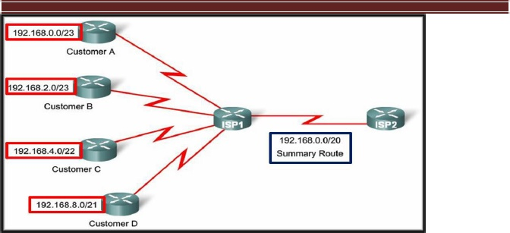
Diagram-1
How to Summarize Routes

Steps to calculate a route summary
- List networks in binary format.
- Count number of left most matching bits to determine summary route mask.
- Copy the matching bits and add zero bits to determine the summarized network address

Calculating Route Summary

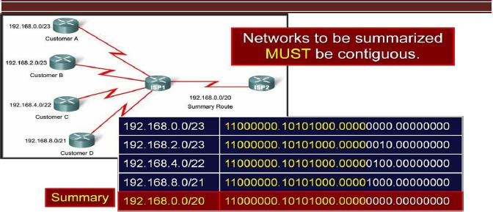
Diagram-2

Step 1: Subnet 10.1.0.0/16, eight more bits are borrowed again, to create 256 subnets with a /24 mask. The mask allows for 254host addresses per subnet. Subnets range from:
10.1.0.0 / 24 to 10.1.255.0/ 24.

Step 2: Use the same process for subnet 10.2.0.0/16.

Step 3: Subnet 10.3.0.0/16, 12 more bits are borrowed again, to create 4,096 subnets with a /28 mask. The mask allows for 14 host addresses per subnet. Subnets range from:
10.3.0.0 / 28 to 10.3.255.240/ 28

Step 4: Subnet 10.4.0.0/16, four more bits are borrowed again, to create 16 subnets with a /20mask. The mask allows for2,046 host addresses per subnet. Subnets range from:
10.4.0.0 / 20 to 10.4.240.0 / 20

VLSM Example
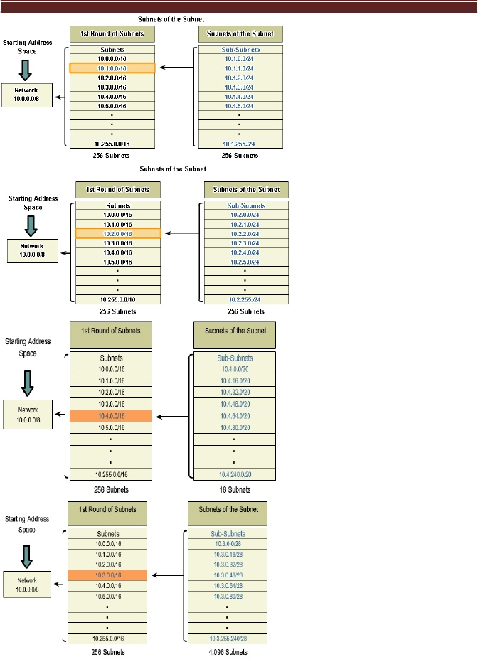
Diagram-3
Diagram-3 above demonstrates the use of VLSM to take a subnetted address and subnet it down again, providing a different range of addresses for issuance.

Subnetting Lab 8 Exercise
Directions. On the space provided before each number, choose the letter of the correct answer.

1. What is a name for routing protocols that support VLSM and CIDR?
A. Interior routing protocols
B. Exterior routing protocols
C. Distance vector routing protocols
D. Classless routing protocols

2 Which subnet mask would produce a subnet with up to 30 host addresses?
A. 255.255.255.224
B. 255.255.255.240
C. 255.255.255.248
D. 255.255.255.252

3. The class C networks 200.2.0.0/24, 200.2.1.0/24, 200.2.2.0/24 and200.2.3.0/24 are summarized as 200.2.0.0/22. What name is given to 200.2.0.0/22?
A. Subnet
B. Supernet
C. Default route
D. Groupnet

4. 192.168.1.0 is subnetted with subnet mask /28. Which of the following is a subnet address?
A. 192.168.1.60
B. 192.168.1.100
C. 192.168.1.48
D. 192.168.1.176

5. A point-to-point link has been given the subnet 192.168.7.240/28. How many host addresses are wasted?
A. 4
B. 12
C. 28
D. 44

6. How many host addresses are available on a subnet with the subnet mask 255.255.255.224?
A. 2
B. 6
C. 14
D. 30

7. A network has 50 hosts. What subnet mask would give a subnet with as few as possible unused addresses?
A. 255.255.255.0
B. 255.255.255.128
C. 255.255.255.192
D. 255.255.255.224

8. Which is an advantage of CIDR?
A. Allows administrators to use classful routing protocols.
B. Allows routers to have smaller routing tables.
C. Allows administrators to create subnets.
D. Allows hosts to share public IP addresses.

9. A summary route in a routing table is given as 180.32.0.0/13. Which range of addresses will match this summary?
A. 180.32.0.0 to 180.32.255.255
B. 180.32.0.0 to 180.33.255.255
C. 180.32.0.0 to 180.35.255.255
D. 180.32.0.0 to 180.39.255.255

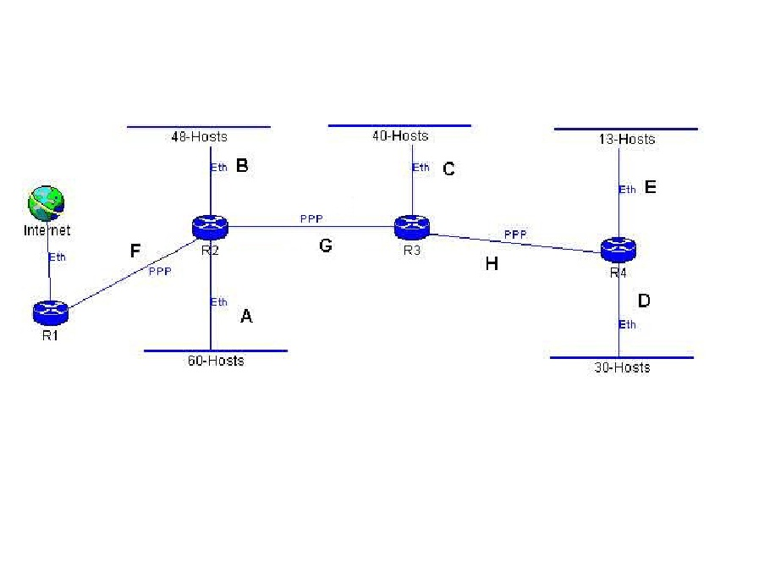
Assume that you have a Class C address block, that is 201.1.1.0/24

According to the topology, plan your IP address networks for segments: A,B,C,D,E,F,G and H by identifying an IP address scheme using a 201.1.1.X addressing. What would you use for X in the fourth octet and what would the VLSM CIDR value be for each segment?

A: _____________________
B: _____________________
C: _____________________
D: _____________________
E: _____________________
F: _____________________
G: ____________________
H: ____________________

